Risk Attributes, Risk Likelihood and Risk Impact

1-Risk Attributes

🔹 Definition
# Source: Chatbot (GPT‑5 Mini) at [8/18/2025]
Risk Attributes are the specific characteristics or properties of a risk that help in identifying, analyzing, prioritizing, and managing it effectively.
They provide detailed information about each risk, making it easier to plan mitigation and control strategies.

🛠️ Common Risk Attributes
# Source: Chatbot (GPT‑5 Mini) at [8/18/2025]
- Risk ID / Name
  - A unique identifier or name for the risk.
  - Example: R001 – Server downtime during peak hours.
- Description
  - Detailed explanation of the risk.
  - Example: High load on the server may cause downtime, affecting users.
- Category / Type
  - Classification of the risk.
  - Example: Technical, Business, Product, Project, External.
- Probability / Likelihood
  - How likely the risk is to occur.
  - Example: High, Medium, Low or 0–100%.
- Impact / Severity
  - Consequences if the risk occurs.
  - Example: High → system outage; Medium → minor delay; Low → cosmetic issue.
- Priority / Risk Score
  - Combined assessment of probability and impact to rank risks.
  - Example: Risk Score = Probability × Impact → helps prioritize mitigation.
- Mitigation / Response Strategy
  - Actions planned to reduce or manage the risk.
  - Example: Add redundant servers to handle peak load.
- Owner / Responsible Person
  - Individual or team responsible for managing the risk.
  - Example: IT Infrastructure Team.
- Status
  - Current state of the risk.
  - Example: Open, Mitigated, Closed, Deferred.
- Detection / Monitoring Method
  - How the risk will be identified or tracked.
  - Example: Server performance monitoring, weekly audits.

📊 Example of a Risk Record
# Source: Chatbot (GPT‑5 Mini) at [8/18/2025]
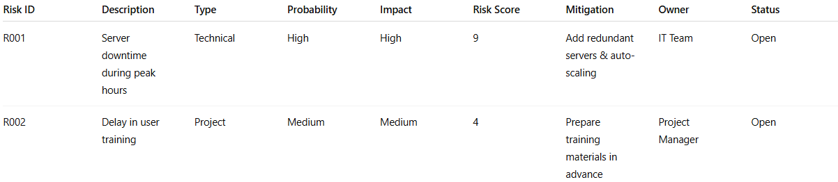
Risk ID | Description | Type | Probability | Impact | Risk Score | Mitigation | Owner | Status
R001 | Server downtime during peak hours | Technical | High | High | 9 | Add redundant servers & auto-scaling | IT Team | Open
R002 | Delay in user training | Project | Medium | Medium | 4 | Prepare training materials in advance | Project Manager | Open

🔑 Importance of Risk Attributes
# Source: Chatbot (GPT‑5 Mini) at [8/18/2025]
- Helps in systematic risk management.
- Supports risk analysis, prioritization, and mitigation planning.
- Provides traceability and accountability.
- Enables reporting and decision-making for stakeholders.

✅ In short:
Risk Attributes = Specific characteristics of a risk (like probability, impact, owner, mitigation) that help in identifying, analyzing, prioritizing, and managing the risk effectively.

2-Risk Likelihood

🔹 Definition
# Source: Chatbot (GPT‑5 Mini) at [8/18/2025]
Risk Likelihood (also called Probability of Risk) is the measure of how likely a risk is to occur.
It helps in assessing the severity of a risk when combined with its potential impact, which is essential for prioritization and mitigation planning.

🛠️ Key Points
# Source: Chatbot (GPT‑5 Mini) at [8/18/2025]
- Range of Measurement
  - Often expressed as:
    - Qualitative: Low, Medium, High
    - Quantitative: Probability from 0% (impossible) to 100% (certain)
- Assessment Basis
  - Historical data from past projects
  - Expert judgment
  - Industry standards or benchmarks
  - Predictive modeling and simulations
- Role in Risk Management
  - Combined with impact to calculate risk score:
Risk Score=Probability (Likelihood)×Impact\text{Risk Score} = \text{Probability (Likelihood)} \times \text{Impact}
  - Helps determine priority and urgency of risk responses.

📊 Example Table
# Source: Chatbot (GPT‑5 Mini) at [8/18/2025]
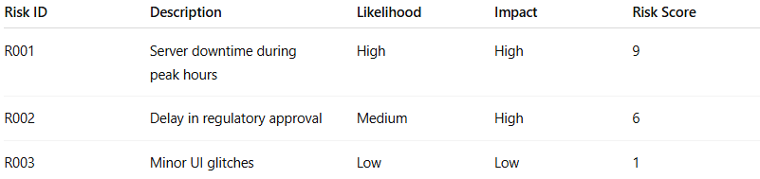
Risk ID | Description | Likelihood | Impact | Risk Score
R001 | Server downtime during peak hours | High | High | 9
R002 | Delay in regulatory approval | Medium | High | 6
R003 | Minor UI glitches | Low | Low | 1
Interpretation:
- High likelihood → risk is more probable and needs careful attention.
- Low likelihood → risk is less probable; may be monitored rather than immediately mitigated.

🔹 Importance of Risk Likelihood
# Source: Chatbot (GPT‑5 Mini) at [8/18/2025]
- Helps focus resources on risks that are more probable.
- Supports risk scoring and prioritization.
- Enables proactive planning and mitigation.
- Reduces surprise events that can disrupt the project.

✅ In short:
Risk Likelihood = The probability or chance that a particular risk will occur, used together with impact to prioritize and manage risks effectively.

3-Risk Impact

🔹 Definition
# Source: Chatbot (GPT‑5 Mini) at [8/18/2025]
Risk Impact is the measure of the potential consequences or severity of a risk if it occurs.
It shows how much a risk could affect project objectives, cost, schedule, quality, or overall success.

🛠️ Key Points
# Source: Chatbot (GPT‑5 Mini) at [8/18/2025]
- Assessment Basis
  - Effect on project schedule (delays)
  - Effect on cost (budget overruns)
  - Effect on scope or quality (defects, incomplete deliverables)
  - Effect on stakeholder satisfaction or business value
- Measurement Scales
  - Qualitative: Low, Medium, High
  - Quantitative: Numeric values (e.g., 1–5, 1–10)
- Role in Risk Management
  - Combined with risk likelihood to calculate risk score / priority:
Risk Score=Probability (Likelihood)×Impact\text{Risk Score} = \text{Probability (Likelihood)} \times \text{Impact}
  - Helps decide which risks need immediate mitigation.

📊 Example Table
# Source: Chatbot (GPT‑5 Mini) at [8/18/2025]
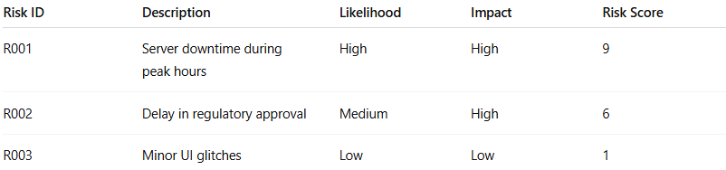
Risk ID | Description | Likelihood | Impact | Risk Score
R001 | Server downtime during peak hours | High | High | 9
R002 | Delay in regulatory approval | Medium | High | 6
R003 | Minor UI glitches | Low | Low | 1
Interpretation:
- High impact → risk could severely affect the project and requires mitigation.
- Low impact → risk consequences are minor; may be monitored rather than immediately mitigated.

🔹 Importance of Risk Impact
# Source: Chatbot (GPT‑5 Mini) at [8/18/2025]
- Helps focus on risks with severe consequences.
- Supports risk scoring, prioritization, and response planning.
- Ensures resources are allocated efficiently to critical risks.
- Reduces overall project failure or major setbacks.

✅ In short:
Risk Impact = The potential severity or consequence of a risk if it occurs, used together with likelihood to prioritize and manage risks effectively.

